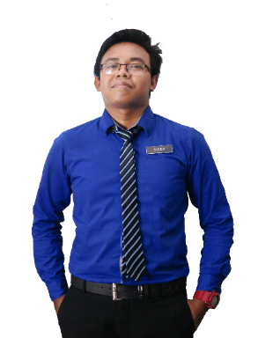

**EDUCATION**

**WORK EXPERIENCE**

**SKILLS**

**REFERENCE**

Principal,

SMK Bandar Baru Sungai Buloh

Phone: 06-4349162Email: smkbbsb@gmai.com

**EN. MUHAMAD SOLEH HUDIN**

**GRAPHIC DESIGN**

**WEB DESIGN**

**TYPOGRAPHY**

**SOFTWARE**

**LANGUAGES**

**MALAY**

**ENGLISH**

**ARABIC**

Creative Resume, 74000 Bandar Puncak Alam, Selangor

resumecreative@yahoo.com

013-2805916

**CONTACT**

* Graphic Design Award 2015, Kuala Lumpur
* Anugerah Guru Cemerlang SMK Bandar Baru Sungai Buloh 2016
* Larian Hari Sukan Negara 2016, UiTM Kampus Puncak Alam
* Volunteer for SUKMA 18, Pahang Darul Makmur
* Creative and Innovation Awards 2017
* Anugerah Perkhidmatan Cemerlang 2017, SMK Kuala Tekal
* Innovation and Creative Product Competition 2015

**ACHIEVEMENT**

**Science Teacher**

Implements curriculum objectives and goals using effective teaching techniques and materials. Develops, in a cooperative manner with the principal and curriculum facilitators, a plan for the improvement and enrichment of instruction.

**2014-2016**

**SEKOLAH MEN KEB KUALA TEKAL, PAHANG**

**SEKOLAH MEN KEB BANDAR BARU SUNGAI BULOH**

**2014-2016**

**Science Teacher**

Implements curriculum objectives and goals using effective teaching techniques and materials. Develops, in a cooperative manner with the principal and curriculum facilitators, a plan for the improvement and enrichment of instruction.

**Lecturer**

Teach at undergraduate and graduate level in areas allocated by the Head of Department and reviewed from time to time by the Head of Department. Carry out research and produce publications, or other research outputs, in line with personal objectives agreed in the Staff review process.

**UNIVERSITI TEKNOLOGI MARA KAMPUS PUNCAK ALAM**

**2014-2016**

Sijil Pelajaran Malaysia

**2014-2016**

**SEKOLAH MEN KEB JELAI (F), GEMAS**

**KOLEJ MATRIKULASI KEDAH, CHANGLUN**

**2014-2016**

Science Stream (Module II)

CGPA: 3.94

**2014-2016**

**UNIVERSITI TEKNOLOGI MARA KAMPUS PUNCAK ALAM**

Bachelor of Education in Science (Hons) Chemistry

CGPA: 3.94

Master of Science

CGPA: 3.94

**UNIVERSITI TEKNOLOGI MARA SHAH ALAM**

**2016-Present**

Master’s degree in Science with four years’ experience teaching high school Science, Chemistry, and Additional mathematic. Certification in teaching Science and also professional in graphic design and video editor.

**ABOUT ME**

Teacher & Graphic Designer

**MUHD SOLEH**